EXPERIMENT:6A

CODE:

clc;
clear;
close all;

%% EXPERIMENT 6(A): MICROWAVE MIXER FREQUENCY CONVERSION

% Given parameters
fRF = 10e9; % RF frequency in Hz
fLO = 9.5e9; % LO frequency in Hz
PRF = -10; % RF power in dBm
PLO = 7; % LO power in dBm
RIF = 50; % IF load in Ohms

%% Theoretical frequency calculations

fIF = abs(fRF-fLO);
fSUM = fRF+fLO;

fprintf('MICROWAVE MIXER FREQUENCY CONVERSION\n');
fprintf('------------------------------------\n');

fprintf('RF Frequency = %.2f GHz\n',fRF/1e9);
fprintf('LO Frequency = %.2f GHz\n',fLO/1e9);
fprintf('IF Frequency = %.2f GHz\n',fIF/1e9);
fprintf('Sum Frequency = %.2f GHz\n',fSUM/1e9);

%% Generate mixer output signal

% Sampling frequency and time
fs = 100e9;
T = 2e-6;
N = round(fs*T);

t = (0:N-1)/fs;

% RF and LO signals
RF = cos(2*pi*fRF*t);
LO = cos(2*pi*fLO*t);

% Ideal mixer multiplication
mixerOutput = RF .* LO;

%% Calculate FFT

Y = fft(mixerOutput);

P2 = abs(Y/N);
P1 = P2(1:N/2+1);

P1(2:end-1) = 2*P1(2:end-1);

f = fs*(0:N/2)/N;

% Normalize spectrum
spectrum_dB = 20*log10(P1/max(P1)+1e-12);

%% Display frequency components

fprintf('\nIDENTIFIED FREQUENCY COMPONENTS\n');
fprintf('------------------------------------\n');

fprintf('Difference frequency = %.2f GHz\n',fIF/1e9);
fprintf('Sum frequency = %.2f GHz\n',fSUM/1e9);

%% Percentage frequency deviation

% Ideal mathematical mixer frequencies
fIF_sim = fIF;
fSUM_sim = fSUM;

devIF = abs(fIF_sim-fIF)/fIF*100;
devSUM = abs(fSUM_sim-fSUM)/fSUM*100;

fprintf('\nPERCENTAGE FREQUENCY DEVIATION\n');
fprintf('IF deviation = %.4f %%\n',devIF);
fprintf('Sum frequency deviation = %.4f %%\n',devSUM);

%% Plot 1: Complete output spectrum

figure;
plot(f/1e9,spectrum_dB,'LineWidth',1.5);
grid on;
xlabel('Frequency (GHz)');
ylabel('Normalized Magnitude (dB)');
title('Microwave Mixer Output Spectrum');
xlim([0 25]);
ylim([-100 5]);

hold on;
xline(0.5,'--r','IF = 0.5 GHz');
xline(19.5,'--g','Sum = 19.5 GHz');

%% Plot 2: IF frequency spectrum

figure;
plot(f/1e9,spectrum_dB,'LineWidth',1.5);
grid on;
xlabel('Frequency (GHz)');
ylabel('Normalized Magnitude (dB)');
title('Intermediate Frequency Spectrum');
xlim([0 2]);
ylim([-100 5]);

xline(0.5,'--r','IF = 0.5 GHz');

%% Plot 3: Sum frequency spectrum

figure;
plot(f/1e9,spectrum_dB,'LineWidth',1.5);
grid on;
xlabel('Frequency (GHz)');
ylabel('Normalized Magnitude (dB)');
title('Sum Frequency Spectrum');
xlim([18 21]);
ylim([-100 5]);

xline(19.5,'--r','Sum = 19.5 GHz');

%% Display result

fprintf('\nRESULT:\n');
fprintf('The mixer produces an IF component at 0.5 GHz\n');
fprintf('and a sum frequency component at 19.5 GHz.\n');

OUTPUT:

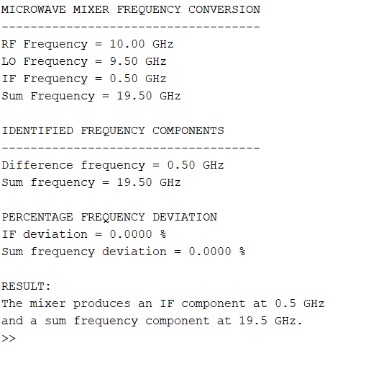

EXPERIMENT:6b
Code:

clc;
clear;
close all;

%% EXPERIMENT 6(B): MICROWAVE MIXER CONVERSION LOSS

% Given parameters
fRF = 10e9;
fLO = 9.5e9;
fIF = abs(fRF-fLO);

PRF = -10; % RF input power in dBm
PLO = 7; % LO input power in dBm
RIF = 50; % IF load in Ohms

% Assumed passive mixer conversion loss
CL_expected = 8; % dB

%% Calculate IF output power

PIF = PRF-CL_expected;

%% Calculate conversion loss

CL = PRF-PIF;

%% Convert IF power into watts

PIF_watt = 10^((PIF-30)/10);

% Calculate RMS voltage across 50 Ohm load
VIF = sqrt(PIF_watt*RIF);

%% Display results

fprintf('MICROWAVE MIXER CONVERSION LOSS\n');
fprintf('-----------------------------------\n');

fprintf('RF Frequency = %.2f GHz\n',fRF/1e9);
fprintf('LO Frequency = %.2f GHz\n',fLO/1e9);
fprintf('IF Frequency = %.2f GHz\n',fIF/1e9);

fprintf('\nINPUT POWER DETAILS\n');
fprintf('RF Input Power = %.2f dBm\n',PRF);
fprintf('LO Input Power = %.2f dBm\n',PLO);

fprintf('\nOUTPUT POWER DETAILS\n');
fprintf('Assumed IF Output Power = %.2f dBm\n',PIF);
fprintf('IF Output Power = %.4e W\n',PIF_watt);
fprintf('IF RMS Voltage = %.4f V\n',VIF);

fprintf('\nCONVERSION LOSS\n');
fprintf('Conversion Loss = %.2f dB\n',CL);

%% Compare with expected range

fprintf('\nPERFORMANCE ANALYSIS\n');

if CL >= 6 && CL <= 10
fprintf('Conversion loss is within expected passive mixer range.\n');
else
fprintf('Conversion loss is outside expected range.\n');
end

%% Plot 1: RF and IF power

figure;
bar([PRF PIF]);
set(gca,'XTickLabel',{'RF Input','IF Output'});
ylabel('Power (dBm)');
title('RF Input Power and IF Output Power');
grid on;

%% Plot 2: Conversion loss

figure;
bar(CL);
ylabel('Conversion Loss (dB)');
title('Microwave Mixer Conversion Loss');
grid on;
ylim([0 12]);

hold on;
yline(6,'--g','Minimum expected loss');
yline(10,'--r','Maximum expected loss');

%% Plot 3: Conversion loss range

CL_range = 6:0.5:10;
PIF_range = PRF-CL_range;

figure;
plot(CL_range,PIF_range,'-o','LineWidth',2);
grid on;
xlabel('Conversion Loss (dB)');
ylabel('IF Output Power (dBm)');
title('Conversion Loss versus IF Output Power');

%% Display final result

fprintf('\nRESULT:\n');
fprintf('The calculated IF output power is %.2f dBm.\n',PIF);
fprintf('The conversion loss is %.2f dB.\n',CL);

CODE:



